South Kyme Parish Council
Biodiversity Action Plan

Contents
1 The Biodiversity Action Plan 3
2 What Why and How 3
What is biodiversity? 3
Why does biodiversity matter? 3
How can we help? 3
3 Management of Public Areas 3
Verges 3
Public Areas 3
4 Planning and Housing 4
5 The Parish Council and South Kyme Community Biodiversity Group 4
6 The Duty of the Parish Council 4
The Objectives of our Biodiversity Policy 5
7 Private Land within our Parish 5
8 The Habitats within our Parish 5
River Kyme Eau 5
Agricultural land/Farmland 6
Hedgerows and trees 6
Gardens 7
Woodlands 8
Golf course. 8
Legislation 8
9 Technical Data 9
10 The Future and Climate Change 9
Annex A The Parish of South Kyme 1
Annex B Public Land 1
Annex C Biodiversity Areas 1
Annex D South Kyme Community Biodiversity Group 1
Annex E The Drainage Ditches Around South Kyme 1

1 The Biodiversity Action Plan
The Biodiversity Action Plan (BAP) was created for the Parish Council by the Biodiversity Working Group in conjunction with the South Kyme Community Biodiversity Group and other members of the community.

This document provides information about current practices on public land and gives an overview of habitats in our parish, identifies threats and provides information to protect biodiversity. It is hoped that the information contained in this plan will enable the Parish Council and residents to safeguard and improve land with regards to biodiversity. It also encourages engagement within the community and further afield to action South Kyme’s BAP to promote and sustain biodiversity.

2 What Why and How

What is biodiversity?
Biodiversity is all the life on earth, from animals, birds, insects and plants to bacteria and fungi. Biodiversity is anything and everything alive in our gardens, hedgerows, woodland, fields, dykes and ditches, verges, lakes and rivers and their banks.

Why does biodiversity matter?
All life on earth has an intrinsic value which we, as our planet’s dominant species, have a duty to protect. Although wildlife can exist without us, we cannot exist without wildlife, so by protecting wildlife we are improving life for ourselves. A natural environment rich in biodiversity delivers numerous benefits for our community including improved health and wellbeing, higher property values and flood prevention.

How can we help?
Wildlife needs protecting and habitats need managing throughout our community. This BAP will identify where the best places are in the village to focus our efforts on protecting wildlife and improving habitats. These places are called Conservation Target Areas (CTAs). This targeted approach helps to concentrate our limited resources of the community to help implement our BAP. Conserving and enhancing biodiversity is important, wherever it is. The CTA approach does not imply that areas outside the boundaries have no biodiversity, or that biodiversity there should not be protected and enhanced. Our community can provide vital help by appreciating, protecting, and enhancing biodiversity in the local area.

Some species are protected by European and UK Law and need to be considered in all Parish Council decisions and operations. Before any decisions are made or work begins, protected species and/or habitats must be considered.

3 Management of Public Areas
South Kyme has a population of around 400, living in approximately 170 houses in the parish (Annex A). Only a small area withing the parish is public land; this includes the area around the Sleaford Navigation Monument, plus a section of riverbank running alongside the Kyme Eau adjacent to the A1395, which includes the picnic area (Annex B) and fishing platforms.

Verges
The Parish Council manages the roadside verges adjacent to the to the B1395 on behalf of Lincolnshire County Council (LCC). The Highway Authority for LCC has a statutory duty to ensure the safety of the highway, and this includes the cutting of grass verges for example where grass impedes visibility at road junctions or through bends. They also cut a 1.1m width alongside the road edge in rural areas for pedestrians and other vulnerable road users to use where there are no footways. Currently their policy is to cut all verges three times annually, although a more frequent cutting regime has been agreed within the confines of South Kyme to aid visibility for drivers.

Verges within the parish are currently cut by Village Tidy Group (VTG) volunteers, usually on the last Saturday of the month during growing seasons.

Public Areas
The Village Tidy Group (VTG) volunteers also mow the grass in other public areas within the parish such as the riverbank and around the fishing platforms. The current Parish Council recognised, from the Parish Meeting in June 2023, that villagers were keen to see that grass on the public areas and riverbanks were kept short (mown monthly) to improve aesthetics, enable easier access and to make it more accessible for owners walking their dogs. Villagers also expressed the view that the grass cut around the flower boxes should be kept short. These requests were passed onto the VTG volunteers who maintain the areas accordingly.

Where possible every opportunity should be considered to increase biodiversity on the limited amount of public land that we have. Therefore, the Parish Council have been liaising with the South Kyme Community Biodiversity Group to identify areas of land that can be used for biodiversity. These are shown on the map at Annex C. This land will be managed by the South Kyme Community Biodiversity Group with the agreement of the Council and influenced, where appropriate, by the Parish Meeting.

4 Planning and Housing
Another area where the Council can influence biodiversity is through the planning system. Wherever possible housing developments should have considered being built sustainably, having a positive impact on wildlife and adopting nature-based solutions as we transition to a sustainable future. The house-building industry is uniquely placed in having an opportunity to create not just houses, but sustainable communities, where people thrive alongside wildlife.

The Central Lincolnshire Local Plan contains planning policies and allocations for the area, which the Parish Council will rely on when responding to the Planning Authority.

A NHBC report combines design concepts, practical solutions and best practice case studies that place ecosystems at the centre of the house-building process. This report is a guide to the practicalities of building new homes in a sustainable way that enhances wildlife, develops climate resilience, and improves people’s health and wellbeing. The Parish Council supports the use of this guidance in housebuilding.

The land surrounding South Kyme can become flooded which is available at Flood Map for Planning and this should be considered in conjunction with other planning considerations. With regards to planning and biodiversity our aims are:
- To consult the Central Lincolnshire Local Plan to ensure its objectives are met.
- Encourage native hedges, shrubs and trees to be planted. Where fences are used ensure a 15cm hole is created to allow hedgehogs to pass.
- Encourage green walls, or roofs to existing and new buildings.
- Encourage native flower rich grasslands.
- Encourage Sustainable urban Drainage Systems

5 The Parish Council and South Kyme Community Biodiversity Group
The Parish Council strives to increase biodiversity with the support of its residents. The Parish Council recognises the need for greater biodiversity and supports the South Kyme Community Biodiversity Group to improve biodiversity in the parish and share good practice. The group have undertaken a variety of actions and activities which can be seen in Annex D. This group works with the community to enhance and promote biodiversity and is always looking for volunteers to help improve the environment.

6 The Duty of the Parish Council
Under the 2021 Environment Act, public authorities (including town and parish councils) operating in England must consider what they can do to conserve and enhance biodiversity. Government guidance published on 17 May 2023 clarifies that, as a public authority, town and parish councils must:

- Consider what they can do to conserve and enhance biodiversity.
- Agree policies and specific objectives based on their consideration.
- Act to deliver their policies and achieve their objectives.

Town and parish councils, unlike other authorities, are not obliged to publish a report on their actions, but the Government guidance required all public authorities to complete their first consideration of what action to take for biodiversity by 1 January 2024; the production of this BAP completed this requirement and we now hope to adopt the BAP as council policy and to take forward its concepts as our objectives for the future.

The Objectives of our Biodiversity Policy
- To increase biodiversity in public areas and encourage increases throughout the Parish as laid out in the BAP.
- To use native and sustainably sourced trees when planting new trees on Council land, but to prioritise natural regeneration wherever practicable.
- To leave dead wood, standing or lying, safely in place to provide additional habitat.
- To maintain planted trees and give them the best chance of survival.
- To reduce / eliminate the use of herbicides, pesticides, and peat.
- To implement measures to prevent the spread of invasive species and plant disease.
- To create dedicated spaces for wildlife.
- To plant and encourage species for pollinators.
- To promote grass cutting policy that encourages biodiversity.
- To inspire our community to increase biodiversity throughout the Parish and to enjoy it!

7 Private Land within our Parish
Houses within the village are either privately owned or tenanted. Away from the village the wider area is owned or managed by a relatively small number of farmers. Intensive arable farming is the predominate use with some livestock. There is a large free range hen operation to the east of the golf course with significant areas of young woodland and an intensive duck farm southwest of the church. Pheasants are reared in and around some of the few woodlands in the Parish for shooting.

Whilst the Parish Council has very little control over private land use, it can act as a catalyst to help others
understand the scale of the biodiversity crisis, and how individual and collective action can make a real difference to biodiversity. The following information will help parishioners increase biodiversity.

8 The Habitats within our Parish

River Kyme Eau
The River Slea, which is called the 'Kyme Eau' between Ferry Farm (a mile or so to the west of South Kyme) to Chapel Hill (around 5 miles to the east of South Kyme) runs parallel to the main road through the village, passing under three bridges, and eventually flowing into the River Witham at Chapel Hill. The river was once navigable from the Witham to the market town of Sleaford.

The Kyme Eau is part of a land drainage system and river levels are set by the Environment Agency (EA) and can vary daily, this is due to rainfall, drainage requirements etc. South Kyme Fen was drained in the late 18th century, prior to that it was marshland with summer grazing, ponds and decoys. It was rich in wildlife habitat. The draining resulted in flat, dry, low lying agricultural land, which is still supported by a system of drainage channels and man-made rivers (dykes and drains), as well as automated pumping. As the land has drained, the level of the land has continued to sink, and the dykes have been built higher to protect the area from flooding. This man-made system of drainage is important to prevent flooding by removing floodwater quickly via the river system. Additional information can be found on the Lincolnshire County Council website.

The River Slea and the Kyme Eau along with Head Dyke and the Carr Dyke are home to a wide variety of wildlife. The river is a corridor for wildlife and as such is hugely important, forming ‘stepping stones’ to connect wildlife across the landscape. They also support the wildlife we see outside of those areas, in our gardens and public spaces.

The EA and Black Sluice Drainage Board undertake bank maintenance primarily to reduce flood risk. Their grass cutting takes place periodically on raised earth embankments, where keeping a good grass sward is part of the management of the flood defence. The EA have stated that they try to restrict larger vegetation which do not perform as well during a flood, for example large leafed vegetation is easily ripped out by high velocity water, whereas tightly knit grass generally stays in place and protects the soil beneath from being washed away. Although this may sometimes be detrimental to the promotion of biodiversity the EA will always prioritise flood risk and, health and safety, over biodiversity.

Although the EA manages the Kyme Eau and the riverbanks outside the village, it does not undertake any grass cutting in the village itself. Annex E shows EA’s maintenance of raised banks.

The Council can increase biodiversity by suggesting to residents:
- That they do not canalise the riverbanks and to reverse this process where possible.
- Plant wildflowers and native hedging to encourage biodiversity.
- Encourage the management of trees on riverbanks, as fallen trees damage the banks and restricts the use of the river by barges and other river users.
- To request that natural materials such as coir rolls embedded with reeds, rushes etc. are used to repair and strengthen the riverbanks.

Agricultural land/Farmland
Field margins provide buffer strips between farming operations and sensitive habitats such as hedgerows, watercourses, and ditches; they are also an important refuge for biodiversity. They allow an array of natural vegetation, providing nesting and feeding sites for game birds and songbirds. Invertebrate species including butterflies, grasshoppers, solitary wasps, and bees are attracted to field margins. Many beneficial predators such as spiders and ground beetles which feed on a variety of foods, especially traditional crop pests such as aphids, are reliant on the field margins for part of the year. The high number of invertebrates provides food for farmland birds and mammals such as bats and the presence of small mammals may also attract barn owls. The field margins act as a valuable wildlife corridor for a range of species including invertebrates, birds, small mammals, reptiles and amphibians enabling wildlife to move to neighbouring habitats, or between hibernation and breeding habitats.

The land around South Kyme is predominantly agricultural land. Over the last 80 years agricultural practices have changed resulting in a loss of field margins and hedges. Another change has been the intensification of land use and the increased use of insecticides, herbicides and fungicides, which have been detrimental to wildlife. The Government now provides financial support to improve field margins through the Countryside Stewardship scheme. The funding will support farmers to move to more sustainable agriculture.

Any major change in land use may impact our community and their wellbeing, e.g. the building of a solar farm, electricity pylons etc. These may have a positive or negative effect on biodiversity.

To improve biodiversity the Council can:

- Promote information on biodiversity funding to the farming community.
- Have an open and supportive dialogue with our farmers over the challenges they are facing, their aspirations and plans, and work towards improving biodiversity.
- Discuss major land use changes at Council Meetings where it may impact the community and invite key stakeholders to present their proposals to the community.

Hedgerows and trees
There are many hedgerows in and around South Kyme. Hedgerows are often a boundary feature, dominated by tree and shrub species and used to enclose fields, woods and property. Hedges provide a home for many forms of wildlife. Their wildlife value is frequently complemented by semi-habitats, e.g. an adjacent bank ditch, field margin, or verge. Hedgerows are typically linked together to create a network of wildlife corridors, often through intensively farmed landscapes, and help link other important habitats such as woods, ponds, grasslands and wetlands.

Hedgerows can support hundreds of species of plants and animals, as well as being an important food source, especially in winter. The sheltered herb rich hedge margins can support many butterflies and other invertebrates, including the nationally notable leaf beetles, and species which feed on them and their larvae. Older hedgerows tend to be those which support the greatest diversity of plants and animals.

Species-rich hedgerows are those which on average support 5 or more woody species in a 30m length. Even in intensively farmed landscape, hedges still provide valuable blossoms, berries, and shelter. Many mature and veteran trees can be found within hedgerows. Better connectivity allows wildlife to move/colonise freely to access water, food, shelter and breeding habitat, and will allow natural communities of both animals and plants to adapt in response to environmental and climate change. Detrimentally, within village environments hedges have often been replaced with fences and non-native species such as leylandii’.

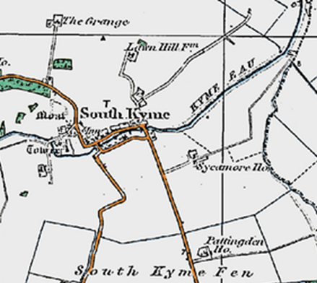
Trees are also valuable habitats and even as they age are quick to attract species of wood-decay. Older fruit trees not only provide habitats but are important hosts for mistletoe and lichens. Their blossom provides valuable nectar for insects, and the fruits provide food for birds such as wintering thrushes and blackbirds.

The only ancient woodland, (woodland continuously covered in trees since at least 1600) is Old Wood to the west of the village adjacent to the B1395). This has been re-planted so is classified as a Planted Ancient Woodland Site. There is no public access at present and to our knowledge the wood has not been surveyed for its biodiversity. Much of its biological value will probably lie in its soil e.g. fungi, insects and some of its ground flora if it has been undisturbed for centuries.

To improve biodiversity the Council can
- Promote the importance of hedgerows, their management and integrity.
- Encourage new planting and natural regeneration of native rich hedgerows.
- Encourage an increase in hedgerow plants and trees.

Gardens
Managed appropriately, private gardens can be extremely rich in wildlife. They can support important small scale habitats including ponds, hedgerows, mature trees, walls, species rich grassland and a wide range of useful flowers. Collectively gardens can combine to form a large habitat for wildlife. It can provide valuable refuges for a variety of wildlife that has come to depend upon both agricultural and garden habitats for its survival. Environmentally friendly methods of gardening are of greater benefit to local biodiversity.

With careful planning even a small garden can increase its wildlife value and for less ambitious gardeners a few simple changes such as a berry bearing bush or insect friendly native flowers can make a notable difference. By providing the right conditions many species, including some that are struggling in the wilds of the countryside, can be encouraged and supported. Good practice includes non-chemical forms of weed and pest control, recycling garden waste, especially composting and less frequent mowing. Feeding the birds and providing nest boxes, insect houses and bat boxes can all help.

To improve biodiversity the Council can

- Support the South Kyme Biodiversity Community Group in their work.
- Encouraging wildlife and ponds in gardens, by increasing awareness, information, and advice on the importance of gardens as habitats for wildlife and how they contribute to biodiversity.

Woodlands
Woodlands are an invaluable asset to the village. South Kyme has several privately owned small woodlands, all out with the village boundary; one adjacent to the B1395 towards North Kyme, another further north of the track to Grange Farm. The woodlands are often isolated preventing habitat corridors for some species.

The UK has lost a lot of woodland over the last couple of centuries, and current woodland is now more protected. New woodland offers an opportunity to extend existing woodlands, create connections between the remaining woods and could help to restore populations of certain woodland animals. New woodlands can provide shelter to adjacent habitats and help develop habitat mosaics that increase the biodiversity of a site, providing that planting does not damage existing valuable habitats.

To improve biodiversity the Council can

- Encourage planting of new woodland especially adjacent to current woodland.
- Encourage the planting of trees to replace specimen ancient trees that have been lost.

Golf course.
In the context of a parish dominated by intensively used farmland, the golf course is an important reservoir for biodiversity. It has trees, ponds, scrubland and areas of longer grass. An artificial hill provides nesting sites for sand martins and probably kingfishers. In the past the whole site was managed with a view to providing suitable habitats. The Greenkeepers’ Association publishes a manual on managing courses for biodiversity.
To improve biodiversity the Council can
- Have an open and supportive dialogue with the South Kyme Golf Club over the challenges they are facing, their aspirations and plans, and work towards improving biodiversity and giving residents more access to the resource.
- Encourage South Kyme Golf Club to enhance their biodiversity and use the Greenkeepers manual to support best practice in course management.

Legislation
The Parish Council is required to act in accordance with legislation. The National Environment and Rural Communities (NERC) Act in October 2006 cemented other commitments to biodiversity contained within a number of European and UK Government Laws, and guidance documents. These include:

- The Wildlife and Countryside Act (1981)
- The Protection of Badgers Act (1992)
- The EC Habitats Directive
- The Countryside and Rights of Way Act (2000)
- Planning Policy Statement 9: Biodiversity and Geological Conservation (2005).

The Environment Agency (EA) has a statutory duty under the Environment Act and the NERC Act to protect, restore and enhance the environment when carrying out its flood risk management activities. Additionally, there is a duty to ensure compliance with the requirements of:

- European and National legislation including
- The Water Framework Directive (WFD)
- Birds and Habitats Directives
- The Wildlife and Countryside and CROW Acts
- Environment Act 2021

9 Technical Data
Biodiversity data helps us understand how biodiversity has changed over time, and how we can use this knowledge to build a future where species can thrive. There does not currently appear to be any technical data held on biodiversity in the Parish. Other sources of data include:

- Kyme Eau water quality - Kyme Eau | Catchment Data Explorer | Catchment Data Explorer
- The Big Butterfly Count - 2020 Butterfly Count
- Big Garden Birdwatch January 2024 - RSPB
- The Big River Watch September 2024 - The Rivers Trust

The Parish Council encourages the community to participate in these national events.

10 The Future and Climate Change
Climate change refers to a large-scale shift in the planet's weather patterns and average temperatures. Since the mid-1800s, billions of tons of carbon dioxide and other greenhouse gases have been released into the air. This has caused global temperatures to rise, resulting in long-term changes to the climate.

These changes in climate are resulting in flooding, heatwaves and a multitude of records being broken. Insects and birds in particular, along with some wildflowers are being threatened as they are unable to adapt to the changing climate. Therefore, it is inherently beholden on all of the community to work together to maintain and enhance biodiversity for future generations.

Annex A The Parish of South Kyme
Parish Map and boundary
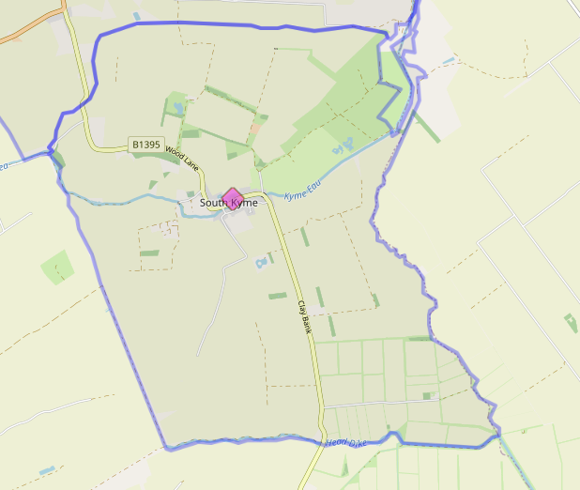

Annex B Public Land
Indicative maps showing publicly owned land in red.

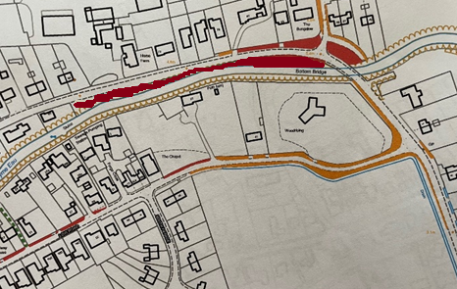
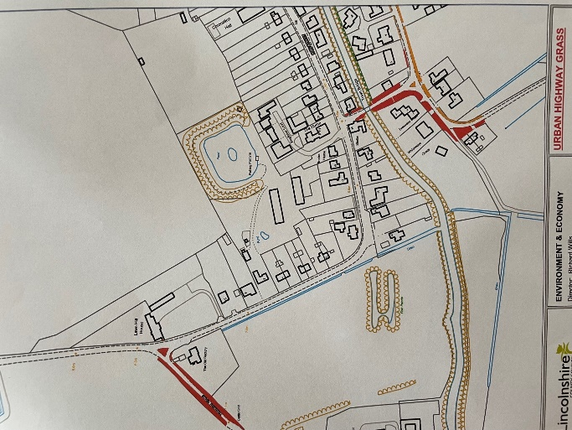

Annex C Biodiversity Areas
Areas set aside for biodiversity planting and management marked in yellow (3 sites)
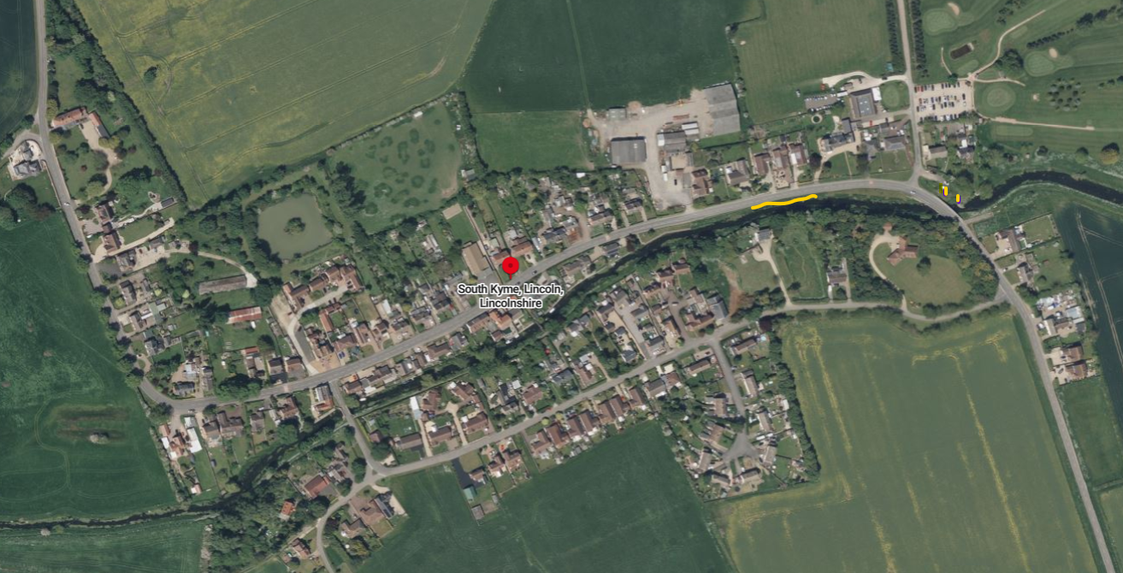

Annex D South Kyme Community Biodiversity Group

The following actions have been supported by the Parish Council in 2023:

- Members of the Parish Council have been instrumental in the creation of the South Kyme Community Biodiversity Group the (SKCBG) in March and wrote the request for funding which was provided by North Kesteven District Council.

- The Working Group has supported a nature walk undertaken by the SKCBG for villages and children in June to learn about wildlife and nature as part of the Great Big Green Week (GBGW).

- The parish council has supported a Bug Picnic in July, a talk about insects and building insect houses.

- A talk on bird species within the parish and the building of bird feeders.

The South Kyme Community Biodiversity Group intends to continue its work into 2024, with a nature walk, and a birds of prey demonstration. Further events are planned for later in the year once additional funding is sourced to support the funding from the Parish Council.

Annex E The Drainage Ditches Around South Kyme

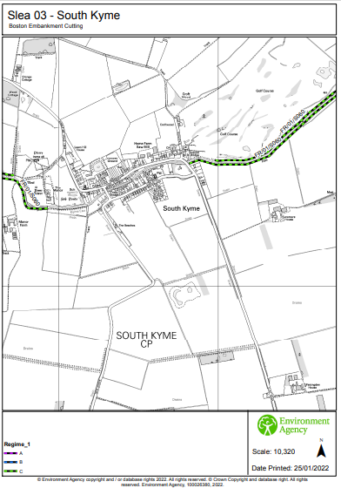

Keepers of time: ancient and native woodland and trees policy in England (publishing.service.gov.uk)

