





Preparing for Emergencies

South Kyme
Community Emergency Plan

Version: 1.0
Issue Date: 11/22/2024 1:06:20 PM
Review Date: January 2027

Aim of this plan
Community Emergency Planning guidance from LCC
This plan has been developed to enable the residents of South Kyme to respond quickly and effectively, to protect both life and property, in emergency situations.
Disasters can strike without warning, anywhere, at any time. To minimise their impact and ensure a coordinated community response, this Community Emergency Plan (CEP) has been developed. By preparing in advance, we can strengthen our community's resilience and provide essential support to emergency services.
This plan is a comprehensive, all-hazards strategy, including provisions for flooding, and has been approved by Lincolnshire County Council and the CERT Leader. It will be activated when at least two members of the Emergency Planning Group determine that immediate action is necessary to respond to an incident and that this action cannot be effectively taken without following the procedures outlined in this document. If the plan is activated, please follow the steps in Section 1 and notify the Lincolnshire Fire & Rescue (LFR) Emergency Planning Duty Officer (EPDO) immediately.

Contents
Section 1: Act 5
Activation 5
Action Steps: 6
ETHANE Form 7
Incident Log 8
Community Impact Assessment (CIA) 9
Key Priorities 11
Section 2: Communicate 12
Key Community Emergency Response Contacts 12
Out of Community Key Contacts 13
Neighbouring Communities 14
Section 3: Resources 15
Community Incident Room 15
Community Places of Safety 16
Emergency Kit 18
Section 4: Local Hazards & Vulnerable People 19
Local Hazards 19
Vulnerable People 20
Section 5: Flood Planning 21
Trigger Points 21
Section 6: Handover & Stand-down 24
Handover Procedure 24
Stand-down Procedure 25
Recovery 25
Recovery Action Steps: 26
Section 7: Appendices 27
A: Community Mapping 27
B: CEP Governance 29
Data Ownership and Usage 29
C: Signatures 30
Record of Amendments 30
E: CEP Publication & Maintenance 31
Data Protection & Indemnity Insurance 31
Training 32
Exercising 32

Section 1: Act

Activation
Always start an incident log.
Effective communication is vital for a successful emergency response. Please refer to the flowchart for guidance.
Whether you initiate your community plan or are requested to do so by the Emergency Planning Duty Officer (EPDO), it is crucial to maintain open communication with the EPDO. Additional support, such as resources or volunteer groups, cannot be mobilised without the EPDO's knowledge.
The EPDO will be the primary contact with emergency services within the incident zone. They will convey your concerns, information about vulnerable individuals, and your 's actions to the Incident Commander.
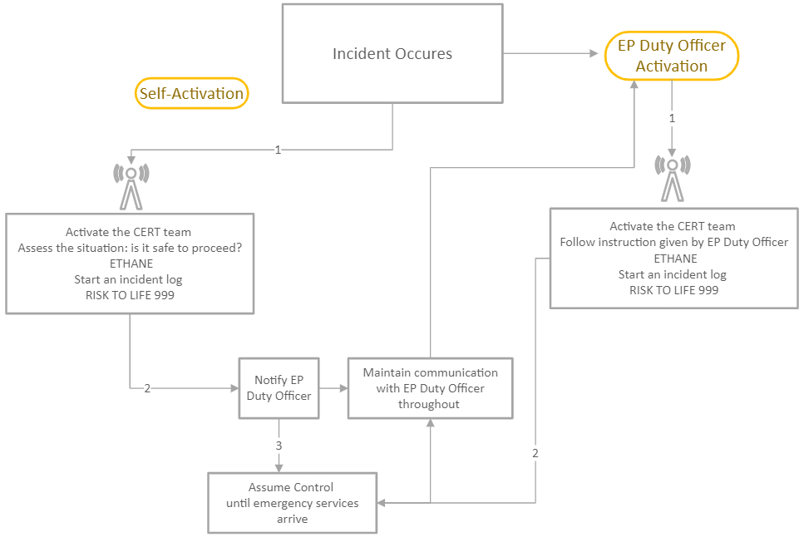

Action Steps:
- Activate the CERT and Gather Information: Use the ETHANE Principle to collect details about the emergency, including location, type, hazards, access, number of people/properties affected, and involved organisations. If life-threatening, call 999 immediately. Start an incident log.
- Contact Emergency Planning Duty Officer: Notify Lincolnshire Emergency Planning Duty Officer via Fire & Rescue Control. Provide your contact.
- Assume Control: Manage the situation until emergency services arrive. Contact additional CERT members. THIS MAY ALSO INCLUDE DOING NOTHING BUT MONITORING THE SITUATION.
- Follow Instructions: Adhere to advice from emergency services.
- Prioritise Safety: Protect yourself and others. Avoid floodwaters, rescue attempts, and clearing blockages.
- Assess Work Location: Determine if working from your current location is safe or if relocation to alternative venue is necessary. Only work outdoors if weather permits.
- Coordinate with the EPDO: Be prepared to establish the shelter if requested.
- Open Emergency Support Centre: If needed, open a place of safety as identified within this plan, or as directed by the EPDO and arrange CERT members to undertake defined roles.
- Warn Residents: Alert local residents about dangers, if safe to do so.
- Support Vulnerable Individuals: Contact and assist those identified in the plan, if safe to do so.
- Gather Resources: Identify and prepare necessary resources for operating a place of safety.
- Monitor Media: Listen to local radio stations (BBC Radio Lincolnshire/Radio Humberside/ Hits Radio) and advise the community to do the same.
- Maintain Communication: Regularly communicate with the CERT, the community and the EPDO.
Important Note: Your Safety is Paramount

ETHANE Form
Time |  | Date
Name of calling organisation:
Name of Caller |  | Tel No

E | Exact Location | What is the exact location or geographical area of incident
T | Type of Incident | What kind of incident is it?
H | Hazards | What hazards or potential hazards can be identified?
A | Access | What are the best routes for access and egress?
N | Number of casualties | How many casualties are there and what condition are they in?
E | Emergency Services | Which and how many emergency responder assets/personnel are required or are already on-scene?
Restricted once complete.

Signature

IMPORT NOTE: Regularly update and advise EP Duty Officer of updates.

Incident Log
Within emergency services, an incident log details decisions, actions and rationales however the primary function of a community-based incident log is to chronologically record problems or concerns raised by community members and CERT members. It serves as a starting point for addressing community issues and allows for decisions actions and rationales to be recorded but secondary to documenting community concerns. Use this table to aid your recording but a notepad will also work just as well.
Date and Time | Location | Description | Reporter | Image or evidence | Follow-up

Community Impact Assessment (CIA)
A community impact assessment (CIA) is a process to evaluate the potential effects of an emergency on your community. It helps identify vulnerable populations, critical infrastructure, and potential hazards. By understanding these factors, we can develop more effective plans and strategies to mitigate risks, respond to the incident, and recover from the emergency more effectively. CIAs also help in identifying community resources and capabilities, which can be crucial for effective emergency management. Use this form, when safe to do so, to capture valuable information. Use one form for each area.
Date: |  | Community | Area/street
Volunteer Name:
Volunteer contact:
Categories | Specific information
Households:
During incident
Number of households affected.
This includes flooded
Households still in situ
Recovery
Households returned to their homes.

Households still displaced
Businesses
During incident
Number of businesses affected.
This includes Flooded
Businesses still in situ and trading
Recovery
Number of businesses trading
Number of businesses unable to trade
Educational Facilities
During incident
Number of schools affected.
This includes flooded
Name and address of affected school.

Educational Facilities
During incident (Continued)
Name and address of affected school.

Name and address of affected school.

Any other educational establishment affected?
Structural Damage Assessment
Roads closed
Bridges damaged
Any other infrastructure damaged?
Environmental Impacts
Livestock issues?
Number of Fields affected?
(estimation of area)
Crops affected?
Health and Welfare
Number of vulnerable people affected.
(in this area of assessment)
Social Care Facilities
Number of Residential homes affected?
Number of Nursing homes affected?
Recovery Clean up
Is there standing water?
If yes, where and how deep? Estimate – do not enter flood water
Is there a build-up of household waste? This includes household refuse.
If yes, where and how much - estimation
Is there a build-up of business waste?
If yes, where and how much - estimation

Key Priorities
Initial response efforts should focus on providing immediate welfare assistance and sometimes, temporary shelter. Avoid becoming responsible for extended community support, such as supplying food or long-term accommodation. If this situation appears imminent, there is a breakdown in communication. Contact the EPDO without delay.
Considerations
- Immediate temporary place of safety (warm and dry)
- Water
Volunteer Briefing
Before deploying volunteers, provide clear instructions and expectations. Emphasise safety, communication, and the importance of reporting incidents.
Briefing Topics:
- Current situation and updates
- Weather conditions and precautions
- Volunteer responsibilities and tasks.
- Time commitments and rotations
- Welfare support
- Communication procedures
- Safeguarding guidelines
- Incident reporting
- Health protection measures
- Stand-down procedures

Section 2: Communicate

Key Community Emergency Response Contacts
The CERT Leader, or their deputy, should contact all CERT members as soon as possible upon activation. Use the contacts below.
CERT Leader | Telephone Number 07713053749
Councillor Carole Chapman (PC Chair) | Telephone Number 07713053749
Email Address
cllr.cchapman-skpc@outlook.com
CERT Deputy Leader | Telephone Number  07880870992
Councillor Tim Kerr (PC Dep Chair) | Telephone Number  07880870992
Email Address
cllr.tkerr.skpc@gmail.com
CERT Deputy Leader | Telephone Number  07766332310
Adrian Chapman (PC Clerk) | Telephone Number  07766332310
Email Address
skymepcclerk@outlook.com
Community Emergency Response (CERT) Membership
Cert Member | Telephone Number  07957387748
Councillor Craig Midgley | Telephone Number  07957387748
Email Address
cllr.cmidgley-skpc@outlook.com
Cert Member | Telephone Number  07484615842
Councillor Pete Goode | Telephone Number  07484615842
Email Address
cllr.pgoode1-skpc@outlook.com
Cert Member | Telephone Number
 | Email Address
Cert Member | Telephone Number
 | Email Address
Cert Member | Telephone Number
 | Email Address
Community Emergency Response (CERT) Flood Wardens
CERT Flood Warden | Telephone Number  07484615842
Councillor Pete Goode | Telephone Number  07484615842
Cert Flood Warden | Telephone Number  07713053749
Councillor Carole Chapman | Telephone Number  07713053749
Cert Flood Warden | Telephone Number

Out of Community Key Contacts
Additional contacts that are important.
LFR Emergency Planning Unit | 01522 843417
Out of hours Emergency planning Duty Officer contact | 0141 397 9363
Fire & Rescue | 999
Lincolnshire Police | 999
Non-emergency calls | 101
General enquiries | 0300 111 0300
East Midlands Ambulance | 999
General Enquires | 08450 450222
Lincolnshire County Council Lead Local Flood Authority | 01522 782070
Out of hours | 01522 785082
Environnent Agency General Enquires (Mon – Fri) | 03708 506 506
Incident Hotline (24hrs) | 0800 80 70 60
Flood line (24hrs) | 0645 988 1188
Local Authority | North Kesteven
Out of hours | 001529 308308
National Grid (Electricity) | 0800 6783 105
National Grid (Gas) | 0800 111 999
Anglian Water | 08457 145145
Severn Trent Water | 0800 7834444
Internal Drainage Board | Black Sluice IDB – 01205 821440
Maritime Coastguard | 999
Humberside Coastguard Operations Centre | 01262 672317
RNLI Skegness | 01752 763011
RNLI Mablethorpe | 01507 447848
Coast watch Skegness | 07902 076605
Coast watch Mablethorpe | 07930 731671
Coast watch Chapel St Leonards | 01754 874311

Neighbouring Communities
Neighbouring communities include Town and parish councils, flood action groups and other local CERT s
Click or tap here to enter text.

Section 3: Resources

Community Incident Room
The CERT should assemble in a designated location to organise emergency response activities. This area should preferably be separate from the evacuation shelter but may not always be feasible.
Name of location | Address | What3Words Locator | Keyholder | Contact No.
South Kyme Coronation Hall | High Street, South Kyme, LN4 4AD | title.boots.inherits | Councillor Carole Chapman | 07713053749
South Kyme Coronation Hall | High Street, South Kyme, LN4 4AD | title.boots.inherits | Robin Eddowes | 07562329314
Alternative if applicable
N/A

Essential resources at this facility will include the Community Emergency Battle Box contents, a copy of this plan, and access to phones and/or the internet.

Community Places of Safety
If it becomes necessary to open a place of safety, contact key holders to access the designated facility. Remember, the place of safety’s sole purpose is to provide temporary shelter and support for displaced individuals.
Primary location
Name of location | Address | What3Words Locator | Keyholder | Contact No.
South Kyme Coronation Hall | High Street, South Kyme, LN4 4AD | title.boots.inherits | Councillor Carole Chapman | 07713053749
South Kyme Coronation Hall | High Street, South Kyme, LN4 4AD | title.boots.inherits | Mr Robin Eddowes | 07562329314
A What3words locator is an invaluable tool for pinpointing the exact location of the place of safety, ensuring everyone knows where to go.
Capacity of shelter | Cooking facilities | Parking | WIFI Access | Other facilities
101 - 200 | Yes | 31 - 50 | Yes | There are sufficient chairs, tables and facilities to feed up to 200 people.
101 - 200 | Yes | 31 - 50 | Publicly Available
Knowing the available resources at the emergency support centre in advance will streamline the setup process for the CERT. Essential items to bring include the emergency kit contents, hi-vis tabards, two-way radios, evacuation paperwork, and pens.
Alternative location
Having a secondary place of safety location is crucial for effective contingency planning. This alternative site provides flexibility in case the primary location becomes unusable due to damage, overcrowding, or other unforeseen events…
Name of location | Address | What3Words Locator | Keyholder | Contact No.
St Mary’s & All Saints Church | Church Lane, South Kyme, Lincoln | Elated.tugging.yachting | Mr Michael Cass (Church Warden) | 07789 347293
St Mary’s & All Saints Church | Church Lane, South Kyme, Lincoln | Elated.tugging.yachting |  | Click or tap here to enter text.
A What3words locator is an invaluable tool for pinpointing the exact location of the place of safety, ensuring everyone knows where to go.
Capacity of shelter | Cooking facilities | Parking | WIFI Access | Other facilities
300 | No | 35 | No | Heating & Electricity
300 | No | 35 | N/A | Heating & Electricity
Knowing the available resources at the place of safety in advance will streamline the setup process for the CERT. Essential items to bring include the emergency kit contents, hi-vis tabards, two-way radios, evacuation paperwork, and pens.

Emergency Kit
A community emergency kit is a pre-assembled, central resource supply designed to assist the Community Emergency Response (CERT) during a disaster or emergency. Provided to CERT members upon completion of the Community Emergency Plan (CEP), the box remains under the CERT 's care.
Name of location &  Address of Emergency Kit | What3Words Locator | Keyholder | Contact No.
South Kyme Coronation Hall | title.boots.inherits | Cllr Carole Chapman | 07713053749
South Kyme Coronation Hall | title.boots.inherits | Mr Robin Eddowes | 07562329314
A What3words locator is an invaluable tool for pinpointing the exact location of the CERT emergency kit, ensuring everyone knows where to find it. It is essential that its contents are regularly checked and replaced as and when required.
Contents checklist
Item | Quantity | Last Checked
Wind-up Radio | 1
Gloves | 10
10-person first aid kit | 1
Emergency whistles | 10
LED torches | 10
Foil blankets | 10
Face masks | 50
Loud hauler | 1
Hi viz tabards | 10
2-way rechargeable radios | 4
Sixty-five litre box and lid | 1

Section 4: Local Hazards & Vulnerable People

Local Hazards
Local risks and threats are potential hazards or dangers that specifically affect our community. They are the potential incidents or situations that could disrupt normal life, cause harm, or damage property. These risks are unique to our community and must be identified and assessed to develop an effective emergency plan for {Community Name}
Types of local risks and threats can be categorised into several types:
Natural Hazards: These are events caused by natural processes. Examples include floods, storms, earthquakes (occasionally), wildfires, sink holes, and extreme heat or cold.
Accidental Hazards: These are events caused by human activities. Examples include accidents (e.g., chemical spills, transportation accidents), infrastructure failures (e.g., power outages, bridge collapses), and intentional acts (e.g., terrorism, cyberattacks).
Health Related Hazards: These are threats to human health and well-being. Examples include disease outbreaks, pandemics, and chemical releases.
Identifying Local Risks and Threats
To effectively identify local risks and threats in our community, it is essential we involve community members to gather information about our collective perceived risks.
Risks and Threats | Description | Actions
Natural Hazards | Floods - medium risk from Kyme Eau. Risk to residents primarily south of river. Floods - low risk from land to the south of Kyme Eau. Risk from low lying land to the coast that lies south of river. | Evacuate at risk residents to Safety location
Accidental Hazards | Risk of road incidents involving HGV's or vehicles carrying hazardous material. Aircraft Incident/Accident. | Incident room and Casualty Assessment at Safety location
Health Related Hazards | Pandemic or outbreak of disease locally. | Incident room and Isolation at the Safety location

Vulnerable People
Identifying vulnerable community members can be complex due to data protection regulations. However, prioritising those who may need extra support during emergencies is crucial. While specific personal data cannot be recorded in this plan, general location information can be helpful. For example, "Church Lane" might indicate potential residents requiring assistance, such as those with mobility issues. This helps the CERT focus support on areas with identified needs.
Known vulnerable locations, such as schools or care homes, can also be included in the plan. It is essential to inform these locations about the community's emergency plan.
The table below assists in identifying such areas.
Location | Type of location? (residential, school etc) | Contact if applicable.  [Not members of the public]
Elderly Individuals throughout the village | Residential street | Parish Council Clerk: Individuals identified through Electoral Register
South Parade | Residential street | Parish Council Clerk: Individuals identified through Electoral Register Details
Low Road | Residential street | Parish Council Clerk: Individuals identified through Electoral Register
Properties within the Parish, south of the Kyme Eau. | Potentially isolated residential properties | Parish Council Clerk: Isolated property individuals identified through Electoral Register
 |  | Click or tap here to enter text.

Section 5: Flood Planning

Trigger Points
South Kyme CERT have clearly defined trigger points to ensure timely and effective response. These triggers can be categorised into various levels of severity, depending on the potential impact and the resources required.
TRIGGER 1
No Notice
What to Do
Start a Log.
Determine if an activation of the CERT is required. If necessary, contact members and place on standby.
Contact EPDO via LFR Control ONLY IF you have activated your group.
Maintain Communication with your CERT.
Flood Alert
 |  |  | 
Flood Alert | Met Office Yellow Weather Warning |  | River Telemetry
What to do at this stage
Flooding is possible.
Stay vigilant and make early preparations for a potential flood.
Trigger 1 Flooding
Monitor the situation through forecasts, the Environment Agency’s ‘Check for Flooding’ service, local radio stations and EPDOs.
Alert CERT members ONLY if activating.
Locate emergency kit, check its contents and ready if needed.
Warn and inform members of the community to monitor the situation, and to ensure properties most at risk have working flood resilience in place.
Flood Alert No Longer in Force |  | Follow stand down procedure
Flood Alert still in force – escalating |  | Take action – go to Trigger Point 2

TRIGGER 2
Notification from member of community or emergency services
What to do
Start a Log.
Determine if an activation of the CERT is required. If required or flooding Activate CERT members.
Contact EPDO via LFR Control ONLY IF you have activated your group.

Flood Warning
 |  |  | 
Flood Warning | Met Officer Amber Weather Warning |  | River Telemetry
What to do at this stage
Flooding is expected.
Immediate action is required to protect yourselves and property.
Trigger 2 Flooding
Continue to monitor the situation.
If appropriate to do so, support people to move valuables, important documentation, electrical equipment and furniture upstairs or to a high place.
Ensure flood resilience measures are working and in place, air brick covers, door barriers etc.
Ensure all people at risk are informed and have been advised to stay alert move pets to safety and have vehicles ready to leave if required.
If necessary, place Emergency Support Centre on standby.
Remain in contact with the EPDO if activated.
Flood Warning No Longer in Force |  | Follow stand down procedure
If escalation, follow advice of emergency services. Go to Trigger Point 3

TRIGGER 3
Follow all advice and guidance given by the emergency services and EPDO
Severe Flood Warning
 |  |  | 
Severe Flood Alert | Met Office Red Weather Warning |  | River Telemetry
What to do at this stage
Severe flooding is expected and is likely to cause significant risk to life and destruction of property.
Prepare to evacuate and cooperate with emergency services.

- Ensure your immediate family and neighbours are safe before taking any further actions.
- If it is safe to do so, check that vulnerable people are aware of the situation and assist where possible.
- Remain in constant communication with EPDO and CERT.
- Follow instruction given by emergency services.

Severe Flood Warning No Longer in Force |  | Follow Stand-down Procedure

Section 6: Handover & Stand-down

Handover Procedure
Upon arrival of emergency services or the EPDO:
- Initial Contact
  - Establish contact with arriving emergency services personal and/or EPDO.
  - Clearly identify yourself and your role as the CERT Leader.
- Situation Briefing
  - Provide a concise and clear overview of the situation, including:
    - Information from your ETHANE report.
    - Actions taken by the CERT.
    - Current Status of the situation as known by the CERT
- Resource Update
  - Inform emergency services or the EPDO about available resources, Including:
    - Number of CERT members
    - Available equipment, if appropriate.
    - Location of any incident room or emergency support centres open and known vulnerable people.
    - Other relevant resources, if applicable.
- Incident Command
  - Clarify with emergency services or the EPDO, the continued role and responsibility of the CERT.
- Documentation
  - Handover all relevant documentation, such as incident logs, evacuation forms etc. to the incoming coordinator.
  - Any donations should be given over to the EPDO (Signatured)
- Confirm Handover
  - Obtain written or verbal confirmation of handover and record in incident log.
- Actions
  - Continue to work under the direction of incoming coordinator until told to stand-down.

Stand-down Procedure
When instructed to stand-down, follow this procedure:
- Task Completion
  - Ensure all assigned tasks are completed or delegated.
  - Verify all equipment and supplies are accounted for.
- Debriefing
  - Conduct a CERT debrief meeting to discuss the incident. Consider what worked well, what did not work so well and, if it were to happen again, what improvements could be considered. Record the outcome.
  - Assign any actions to follow-up.
- Equipment and supplies
  - Clean and maintain any equipment used.
  - Replenish any supplies used.
  - Store equipment and supplies securely.
  - Leave any facilities used in the same state they were found.
- Documentation
  - Complete all relevant paperwork.
  - Submit any reports to the appropriate personnel (EPDO or other official).
- Communication
  - Inform all relevant parties about the stand-down.
  - Provide contact details for follow-ups.
- Demobilisation
  - Dismiss CERT members.
  - Ensure the safe departure for the site.

Recovery
Following significant incidents within the community, the CERT will play a vital role in supporting recovery efforts and facilitating the community's return to a new state of normality. This chapter outlines the CERT’s responsibilities and procedures during the recovery phase.
South Kyme will actively participate in recovery operations by:
- Support recovery activities within the community, for example, helping with clean-up and restoration following flooding.
- Collaborating with relevant agencies and organisations to ensure a comprehensive recovery effort. i.e. sharing local information such as locations of vulnerable people with emergency services and other responding agencies.
- Providing necessary resources and support to affected community members.
- Monitoring the community's progress and identifying ongoing needs.
Liaison with Emergency Planning Duty Officer
To ensure alignment with broader recovery initiatives, South Kyme will maintain close communication with the Emergency Planning Duty Officer and/or, if established, the LRF Communities and Volunteer Coordination tactical cell at the County Emergency Centre. This liaison will facilitate the integration of local recovery actions into wider recovery plans and strategies.

Recovery Action Steps:
- Maintain log.
- Take photographs of affected areas
- Where possible, without putting yourselves at risk of harm/drowning, record flood water depths. DO NOT ENTER FLOOD WATER UNDER ANY CIRCUMSTANCES.
- Support agencies with community impact assessments and data collection. These are to aid investigations and to ensure residents get the right support from agencies.
- Support residents with clearing tasks.
- Do not throw anything away until photographs have been taken and any insurance provider has been consulted.
- Support with community information sessions.
- Participate in any agency debriefing sessions.
- Review and update the South Kyme Community Emergency Plan (CEP).

Section 7: Appendices

A: Community Mapping
Community Information
South Kyme is situated within Lincolnshire and supports a population of 434 people [2021] Census.
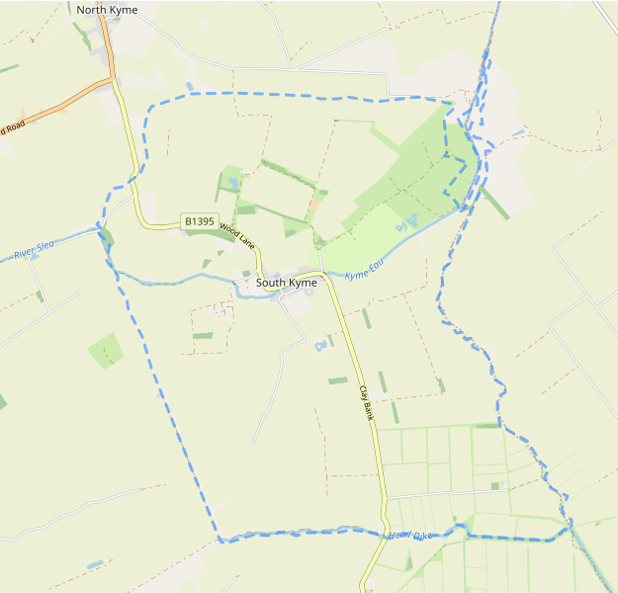 Community Map – Parish Boundary
south Kyme | OpenStreetMap
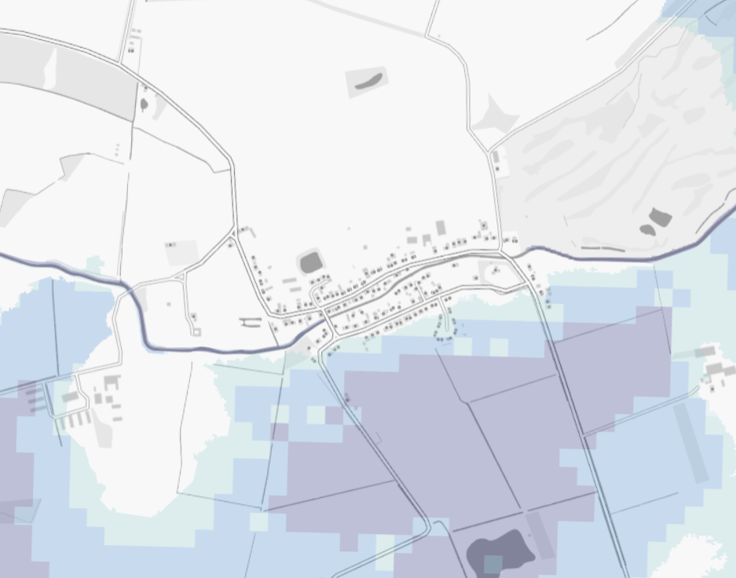 Community Map - Flood Risk
south Kyme | OpenStreetMap

B: CEP Governance

Data Ownership and Usage
This CEP is the property of the South Kyme. Any information gathered during its creation is the responsibility of the group.
We will collect personal data for the following reasons:
Emergency Contact Sharing: On activation of the community Emergency Plan, the group agrees to share contact details with the local emergency planning group and Lincolnshire County Council (LCC) Emergency Planning Unit. This information will be used for warning, informing, and coordinating efforts before, during, and after the emergency.
Data Sharing with Partners: In certain circumstances, LFR Emergency Planning may share this data with other agencies or emergency services. This will only occur when necessary to protect your safety or the safety of others during emergency response and recovery, in line with data protection regulations. For more details on how Lincolnshire County Council handles your data, please request a copy of the LCC Privacy Notice.

C: Signatures
Effective {Date of Approval-by-Approval Authority}, the South Kyme has officially adopted as a dynamic document for use by the South Kyme CERT.
Lincolnshire County Council
Signature
South Kyme | Councillor Carole Chapman
Signature
South Kyme | Councillor Carole Chapman
Signature

Record of Amendments

Date | Details of amendments | Revised by
August 2024 | Community emergency plan template complete review and reformat. 12824SE | EPO SE
October 2024 | Additional CIA added | EPO SE
F be 2026 | Telephone contacts amended and community map and link added | EPO SE

E: CEP Publication & Maintenance
It is essential that this operational plan is up-to-date and accessible to all CERT members. To maintain consistency, plan contacts should be reviewed and updated annually, or as required due to changes or lessons learned. A full plan review should be conducted every two years.
Document Storage
- Electronic copies are held by the EPDO.
- All CERT Members have access to the plan, with a paper copy kept in the CERT Battle Box at {BB location Name}.
A redacted online version is available at {website}.
Plan Review and Exercise
All CERT members should understand their roles and be prepared for potential emergency contact. This plan will be exercised annually in conjunction with the CERT, supported by LFREPU, and as part of wider Lincolnshire County Council/Lincolnshire Resilience Forum exercises. The CERT leader and any deputies will organise the community exercise component.

Data Protection & Indemnity Insurance
This community emergency plan is the property of the South Kyme, and any information gathered during its creation is the responsibility of the CERT.
Personal Data:
Personal data is collected for the following purposes:
In the event of an emergency, the CERT members agree to share contact details with the CERT and LFR Emergency Planning & Business Continuity Service for warning, informing, and coordination purposes before, during, and after the incident.
If necessary, LFR Emergency Planning may share this data with partner agencies or emergency services. Information is only shared to protect your or others’ vital interests during emergency response and recovery, in accordance with data protection regulations. For more information on how Lincolnshire County Council manages your data, please request a copy of the LCC Privacy Notice.

Indemnity Insurance
All volunteers must read and sign the Lincolnshire County Council Indemnity Insurance form before undertaking any voluntary roles on behalf of the authority. To access the form, please click here or scan the QR code.


Training

Date | Name of individual | Training received

More rows can be added by using the TAB key.

Exercising

Date | Exercise | Outcome

More rows can be added by using the TAB key.

